MakeDo Kit Resources

Programming Ideas
Tower Challenge
Participants can work individually or in pairs to build the tallest unsupported cardboard tower possible within twenty minutes. Start the program by sharing pictures of famous towers, and asking participants to reflect on what makes a tower strong. See if they can identify general patterns (i.e., towers often have a bigger base at the bottom, towers are made of triangles, etc.). When time is up, measure all the towers and interview each team about what worked and what they would do different next time.
Bridge Challenge
This is like the Tower Challenge, only participants need to see who can build a bridge that spans the longest unsupported distance.
Knights in Shining Armor
Participants will use MakeDo and cardboard to make armor fit for a knight! After reading an appropriately themed story from your collection, participants will have twenty minutes to work on their armor. Afterwards, they can have a photoshoot in their finest apparel!
Castletown
Have participants work together to create an entire fort. The bigger, the better. Don’t forget to include a drawbridge and a dragon!
Caine’s Arcade
https://vimeo.com/40000072
After watching this video, have participants work together to recreate some of their own cardboard carnival attractions. Leave them out and encourage other patrons in the library to try them out! This can be done over multiple sessions.
Geodesic Domes
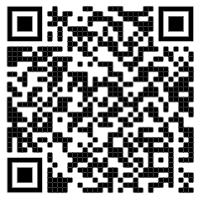
https://www.make.do/blogs/makedo-makers/38999425-makedo-how-to-make-geodesic-dome
By following a simple pattern, participants can build a dome large enough to enclose the entire library! …in theory.

