Circuitry Kit Resource List

Please Note -The following supplies are REQUIRED but not supplied:
- 9V battery for the Snap Circuit
- 4 AA batteries for Squishy Circuits

littleBits STEAM Student Set
Educator Guide
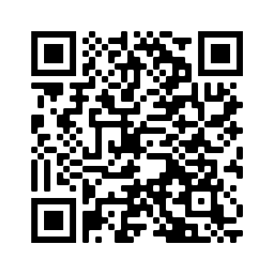
https://s3.amazonaws.com/littleBits_pdfs/littleBitsEducatorsGuide_FINAL.pdf
How-Tos
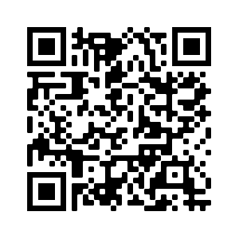https://www.youtube.com/playlist?list=PLHXgG0awHxDqJLZqMEJweD98GWybw2oeC

SNAP Circuits Extreme
Instructions
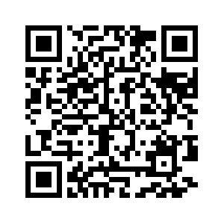
https://www.eduporium.com/blog/tips-and-tricks-snap-circuits/

Squishy Circuits
Instructions and How-To's
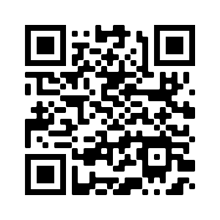  https://squishycircuits.com/projects/ | 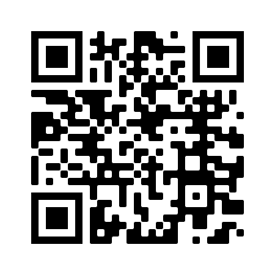  https://www.youtube.com/watch?v=GBuWiFM2T_o
Dough Recipes
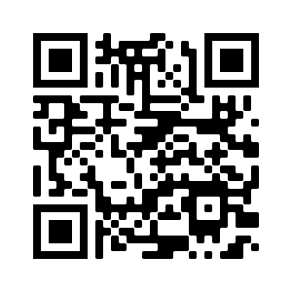
https://squishycircuits.com/recipes/

Copper Tape/ LED Lights/ Coin cell batteries
Instructions and How-tos
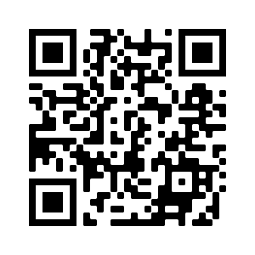  https://www.youtube.com/watch?v=IZGWkCR7T6E | 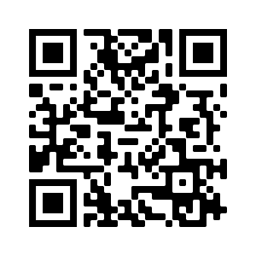  http://www.instructables.com/id/LED-Paper-Flower/
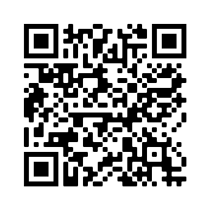  http://www.instructables.com/id/Paper-Circuit-Valentines-Day-Card/ | 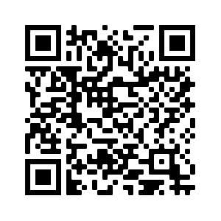  http://www.sciencebuddies.org/blog/2015/04/creative-circuits-with-copper-tape.php
Educators Guide
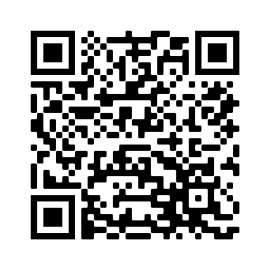
https://makerlessons.weebly.com/uploads/4/3/0/2/43026285/paper_circuits.pdf

MaKey MaKey
Instructions and How-Tos
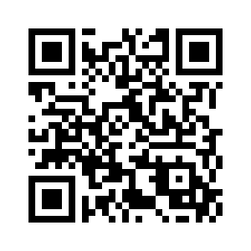  https://makeymakey.com/pages/how-to | 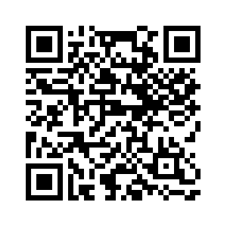  https://learn.sparkfun.com/tutorials/makey-makey-quickstart-guide
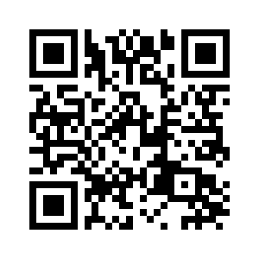
https://scratch.mit.edu/studios/223260/

