KEVA Planks Kit Resource List

KEVA Planks
Project Ideas
https://www.youtube.com/user/KEVAplanks | https://www.youtube.com/watch?v=NhI2Vn2ZsM8
https://www.youtube.com/watch?v=A5zcbyyDDVQ&list=PLQywNo52YEXyrXBj7nVUX-c6YacEetX51&index=8 | https://www.youtube.com/watch?v=UJWWdPeKE_U

Additional Information
https://www.kevaplanks.com

Sample Projects

Portico – 49 Planks
Train – 149 Planks
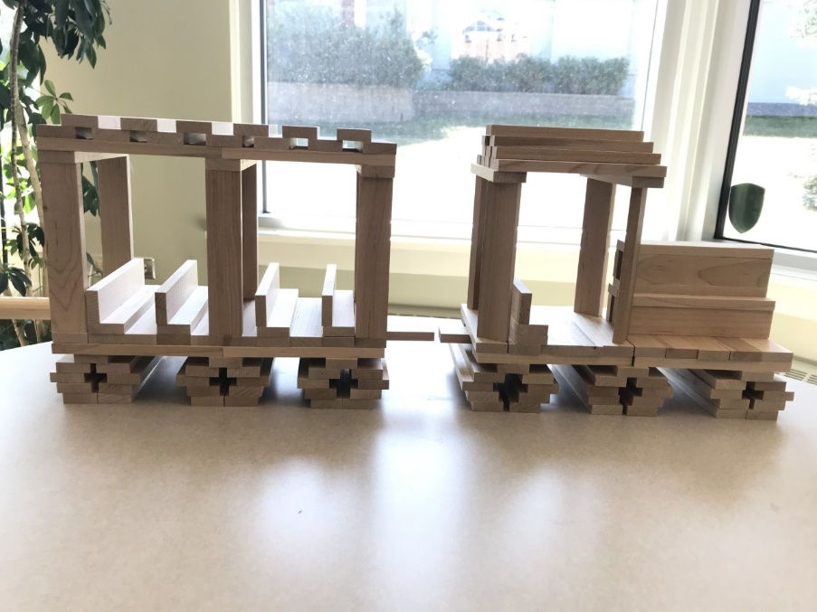
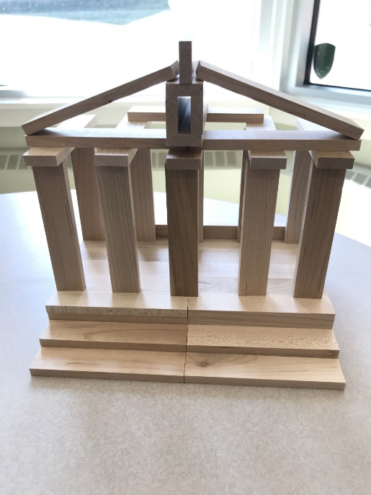

Helicopter – 38 Planks
