Leather Craft Kit Inventory - Detailed List

- 1 Leather Punch
- 20 Leather Stamps
- 8 Prong Chisels
- 3 Rivet setters
- 1 Rivet anvil
- 3 Stitching wheels
- 15 Hand Needles
- 1 Sewing awl
- 4 Sewing awl needles
- 2 Leather awls
- 1 Stitching groover
- 5 Stitching groover tips
- 10 Slot punches
- 1 Leather skiver
- 10 Skiver blades
- 1 Leather Cutting Knife
- 1 V-shaped groover
- 1 Leather glue tool
- 2 Wooden burnishers
- 3 Wool dauber ball brushes
- 1 Precision cutter
- 10 Finger Protectors
- 1 Mallet
- 1 Base Slab
- 2 Bone Folders
- 1 Stitching Pony Clamp
- 4 Files
- 1 Ruler
- 1 Measuring tape
- 1 Scissors
- Consumables
  - 1 Leather & suede glue
  - Thread
  - Rivets
  - Leather samples for practice
- Books
  - Leathercraft: Inspirational Projects for You and Your Home
  - How to Work with Leather

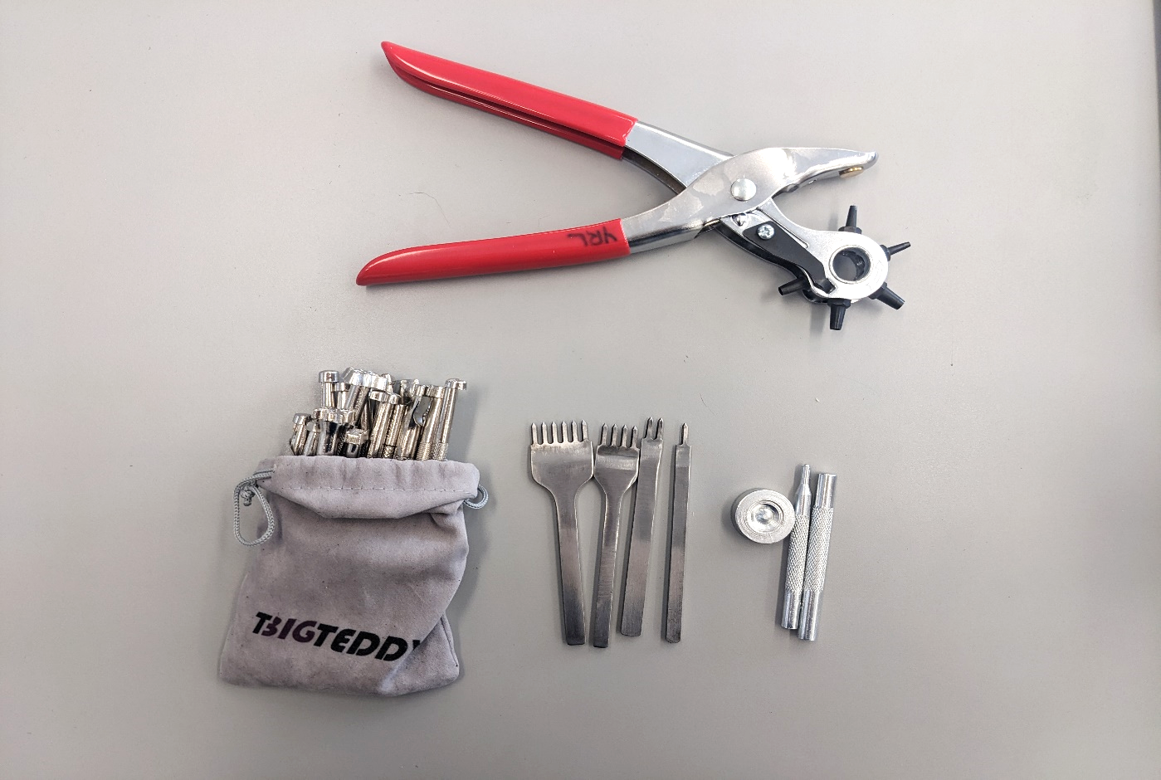
Leather Punch
Prong Chisels
Rivet Setters & Anvil
Leather Stamps

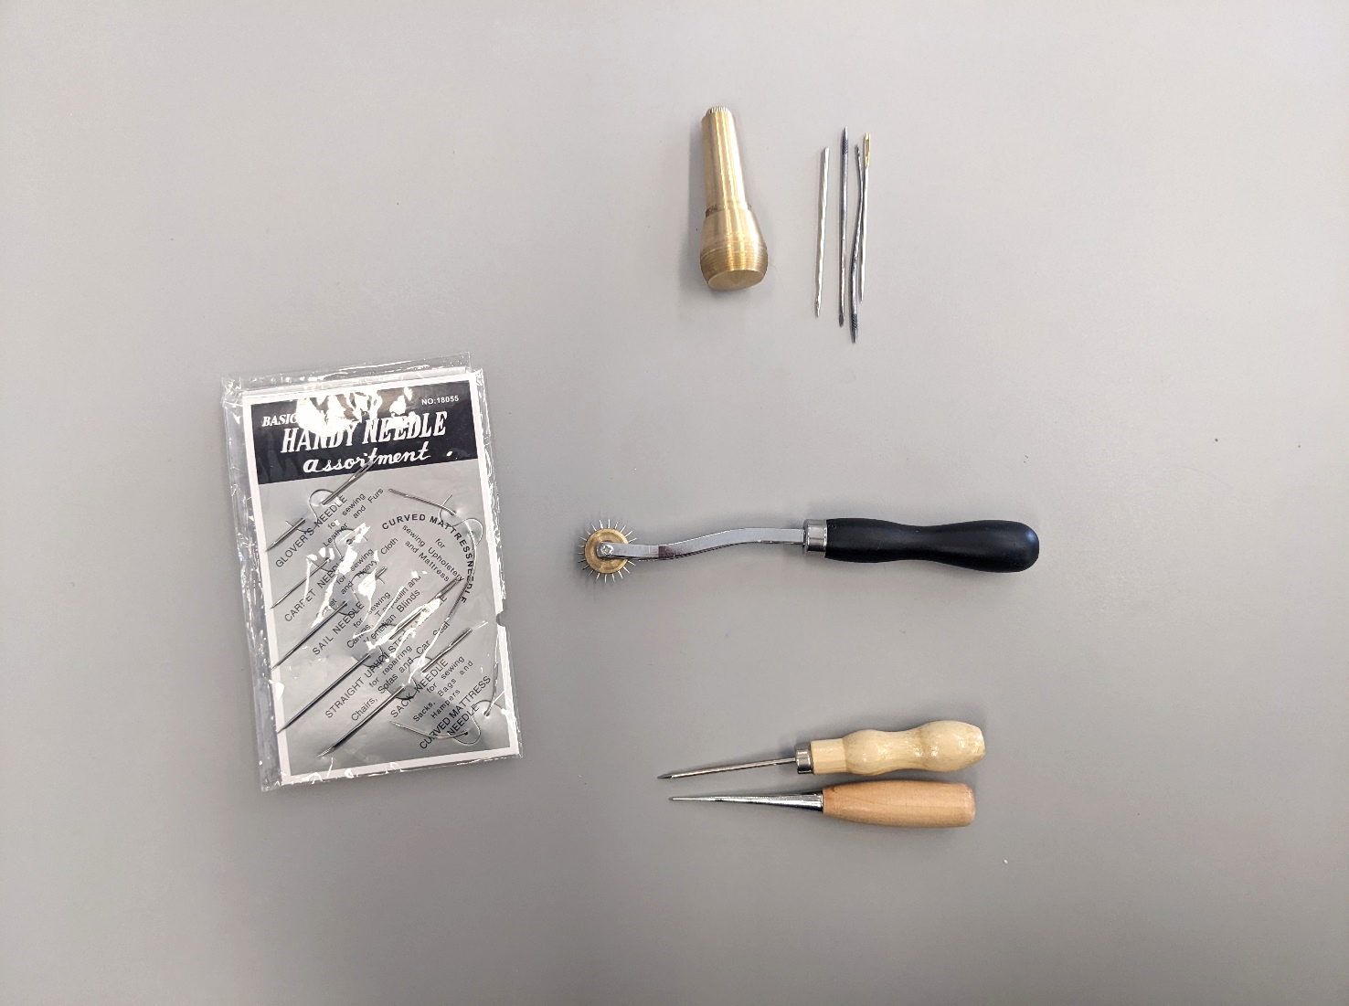
Sewing Awl & Needles
Leather Awl
Stitching Wheel
Hand Needles

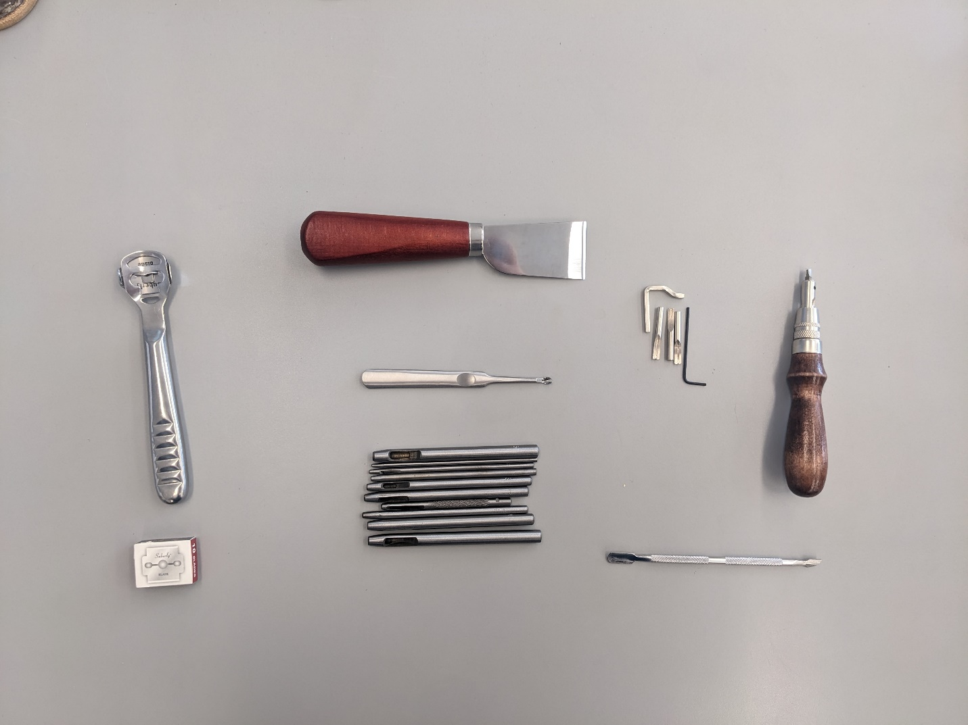
Leather Cutting Knife
V-Shaped Groover
Leather Glue Tool
Stitching Groover & Tips
Slot Punches
Leather Skiver & Blades

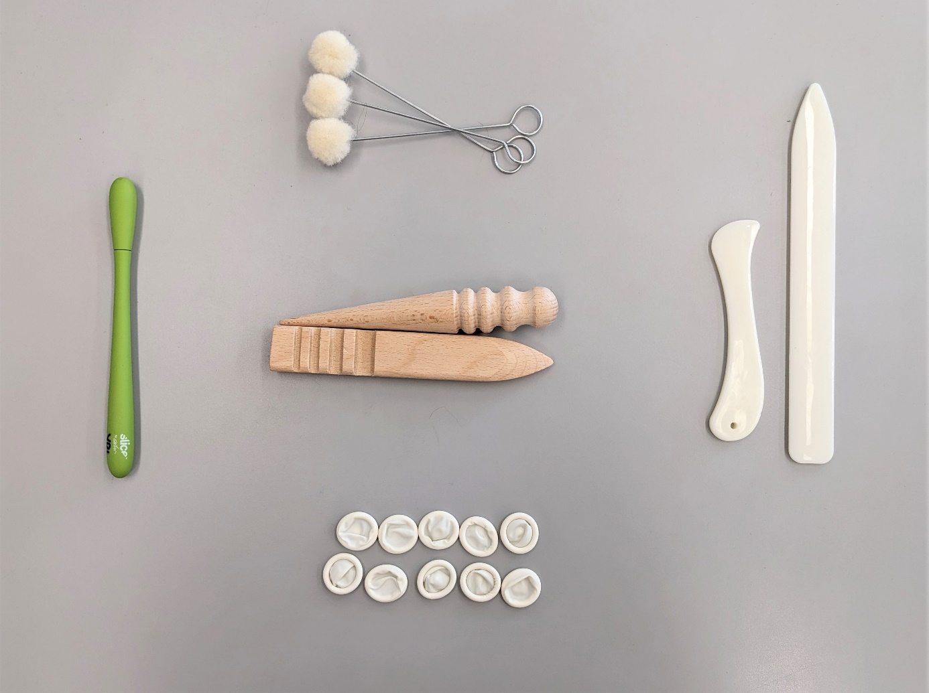
Finger Protectors
Precision Cutter
Wooden Burnishers
Bone Folders
Wool Dauber Ball Brushes

