Presenting Your



Library Budget to Council

Things to consider when presenting your budget to council

# CREATING A BUDGET

When creating your operational budget, it is important to understand where your funding is coming from and how it is being used. Ensure that you are prepared with key numbers for your budget presentation. Being able to answer questions without referencing your documents is ideal. Your budget should start with an outline of all your operational expenses. Include the cost of any service changes implemented due to the Plan of Service.

You should include Budget Notes to explain how the funding will be used, why it is necessary, why the amount might have changed from the previous year, or if the line is funded by a specific grant or donation. In your presentation, be sure to connect budget lines to municipal priorities.

The second section of your budget will outline all your operational known incomes (not including your municipal and county contributions). Use the previous year's data to estimate your Library Service income (fees and fines, room rentals, etc.) You will need to calculate your over/under amount (income - expenses) so you know how much you need to ask for in your presentation to the council.

Example: $91 expenses - $63 income = $28 shortage

The shortage should equal the increase in municipal and county contributions the library asks for. The division between town and county funds can be calculated based on service populations.

Your presentation does not need to include your entire budget. Prior to your presentation, provide a copy of your complete budget to the council and go over key budget lines and requirements. Be sure to link any increase requests to supporting municipal priorities.

# BEFORE THE PRESENTATION

## Gather information

Every municipality has its own goals, ranging from improving infrastructure to attracting new residents. Whatever these goals are, it is important that the library is aware of them and targets its services and budget needs to support them. It is also important to understand the context surrounding the council meeting you are attending—what else does the municipality have going on, and how might the library rank on its priorities list?

Reach out to council or administration to learn the municipality’s goals and priorities. The municipality might have a strategic plan that is easily

accessible. Reviewing the minutes from council meetings on a regular basis can also be helpful so you know what the current priorities are.

Create connections between the municipality's goals and what the library is doing.

## Example

Municipal Goal: Attract new young families Library Service: Story time and family programs.

Municipal Goal: Raise awareness of community services Library Service: Provide welcome packages and resource materials to all patrons

# BEFORE THE PRESENTATION

Create a takeaway document

Using the previous year’s annual report statistics and the current year's actions, create a takeaway document outlining the highlights of library service and how they directly contribute to the goals of the library’s plan of service and the municipalities' strategic goals.

Examples of what you could include:

library use statistics (circulation, WIFI usage, computer use, reference questions, patron visits, program attendance, etc.)

Impact statements Patron testimonials Stories

Plan of Service summary

Examples of community partnerships and contributions

View an example of a takeaway document created for the seven library systems in Alberta to advocate to the provincial government. You'll notice that the government's goals are tied back to the library’s actions.



      

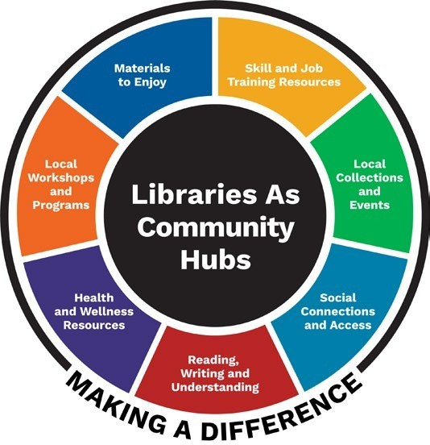In a typical year, public libraries in Alberta are visited more than 20 million times, circulate more than 35 million items, and offer tens of thousands of programs for all ages. Public libraries

are welcoming community hubs that connect, inform, and inspire people of all ages. Libraries help to build a stronger province by creating opportunities for all.

Libraries Deliver Value Beyond Words

Libraries are one of the most effective and impactful uses of public funding. Strong libraries equal strong

communities. Libraries help ensure that all Albertans have access to broadband internet, authoritative information, technology, tools, and services needed to help our province thrive. Equitable access to resources and materials provided by libraries ‘levels the playing field’ and enables all Albertans to learn, grow, and flourish.

Libraries are the heart of rural Alberta

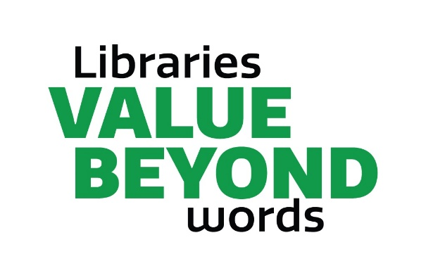



**Health**

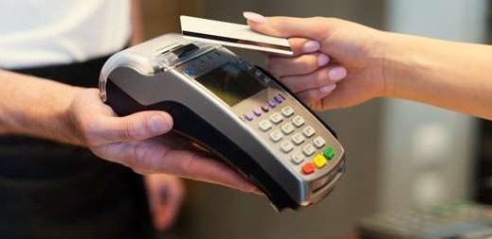

**Economic Development**

Businesses choose to locate in communities with libraries. They value libraries as an essential quality-of­ life amenity for their employees and families.

Libraries support economic development by providing resources for people to start a business, upgrade skills, or learn about career options.

Libraries bring people together, which is a significant factor in mental well-being. For example, moms and toddlers can enjoy story time, providing socialization and literacy support. Isolated seniors can play cards and teens can make friends during game night. The library is a safe, enjoyable community hub that supports mental health through social connection.



**Education**

Libraries encourage literacy for people of all ages,

help newcomers who have English as a second language and connect people and the world. Free internet access is a critical educational support for families and people living in poverty.



**Environment**

Libraries can also provide peer-reviewed, evidence­ based resources on health matters, making access to reliable information easy for everyone.

Librarians are available to help people find evidence­ based resources that are credible and reliable. In times of misinformation, falsehoods and conjecture,

libraries can be a force for objectivity and truth.

**s;**

**MARIGOLD**

LIBRARY SYSTEM

Libraries help reduce waste and over-consumption by lending books, movies, materials and resources time and time again. This is the 'original' recycling program! Library circulation gets the longest life out of each item by enabling as many people to

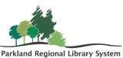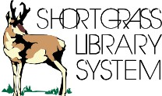use it as possible.



**Credible Information**



Yellowhead Regional Library

----------- Can we count on your support?----------

# THE PRESENTATION

[If the Library already has a positive relationship with council and](http://support.prl.ab.ca/index.php/services/advocacy-communications-marketing-support/) [administration, each budget presentation will become easier.](http://support.prl.ab.ca/index.php/services/advocacy-communications-marketing-support/)

## Things to Consider When Creating the Presentation

Don't include any jargon or acronyms

Prepare a takeaway document to leave with council—no more than one double-sided page. Include stories, testimonials, and meaningful photos. Have speaking notes for the board member presenting. Library managers should be in attendance to provide support and answer questions about operations.

Highlight significant budget lines and explain the necessity for the increases/decreases. It is not necessary to go through the whole budget line by line.

Highlight 1 - 3 points from the takeaway document. Tie each point to “How the library supports the municipalities' goals”

Highlight 1 – 2 points about the library’s future goals and how those goals will support the community.

# THE PRESENTATION

## Things to Consider When Presenting

**When Presenting**

Investigate the technology available and ensure the presenter is comfortable with it (e.g., PowerPoint, projector, Zoom).

Send the presentation, handouts, and budget documents to

the administration in advance so that it gets into the council package. Practice - memorize your opening and ensure your pronunciation and pace is acceptable.

Don't read your slides; bring notes if necessary Try not to read directly from the speaking notes.

Anticipate and prepare for questions and objections

Be aware of the time allotted and practice the presentation to ensure you are within the time limit.

Keep speech/answers short and to the point. Allow time for questions.

Be respectful. The library is one of many crucial services in a community, and councils are bombarded with funding requests.