Button Maker Resource List

When looking online for resources, remember you are looking for Model 225 or 2.25” round buttons.

Instructions and Layouts
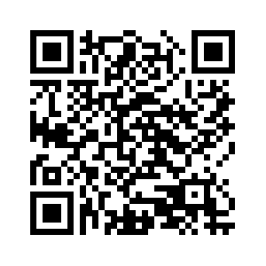https://www.tecre.com/button-maker-downloads.html#TaglineLayouts | 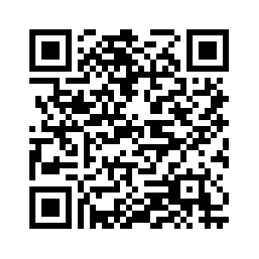  https://www.tecre.com/blog/2014/11/free-resources-for-button-maker-machine/

Inspiration and Ideas
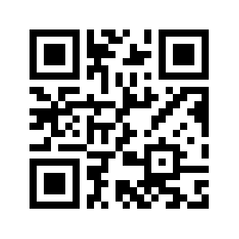http://www.thebuttonguy.net/ | 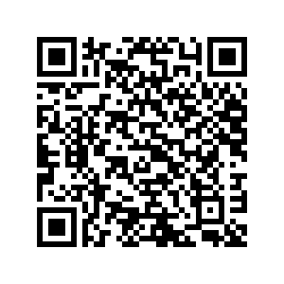 http://www.teenlibrariantoolbox.com/2016/06/makerspace- button-maker-challenges/

How-To Videos
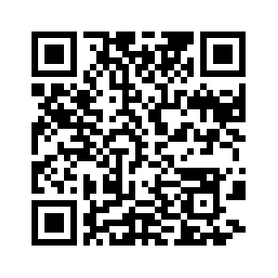
https://www.youtube.com/channel/UCJ9x75axZZM2_ys0OwknIoQ

Templates
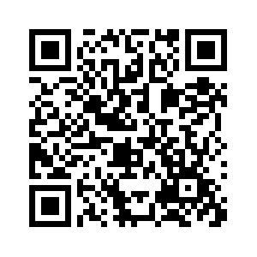  http://thebuttonguy.net/files/Templates/PDF/2_25InchSizeButtonTemplate.pdf | 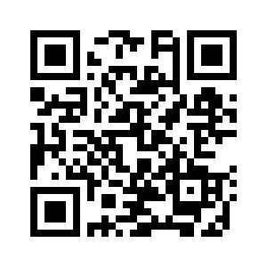  https://www.umakebuttons.com/pages/templates

