Mini Circuitry Kit Resource List

littleBits STEAM Student Set
Instructions and How-Tos
https://s3.amazonaws.com/littleBits_pdfs/littleBitsEducatorsGuide_FINAL.pdf | https://www.youtube.com/playlist?list=PLHXgG0awHxDqJLZqMEJweD98GWybw2oeC

Squishy Circuits
Instructions and How-To's
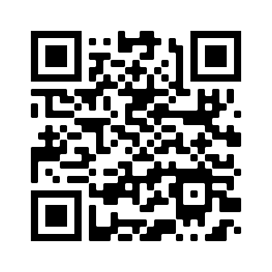  https://squishycircuits.com/projects/ | 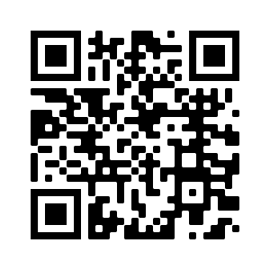  https://www.youtube.com/watch?v=GBuWiFM2T_o
Dough Recipe
https://squishycircuits.com/recipes/

Copper Tape/LED Lights/Coin cell batteries
Instructions and How-To's
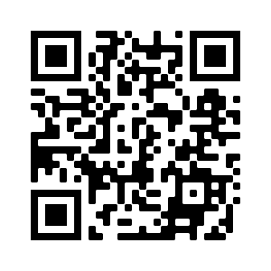  https://www.youtube.com/watch?v=IZGWkCR7T6E | http://www.instructables.com/id/LED-Paper-Flower/
http://www.instructables.com/id/Paper-Circuit-Valentines-Day-Card/ | http://www.sciencebuddies.org/blog/2015/04/creative-circuits-with-copper-tape.php
Educators Guide
https://makerlessons.weebly.com/uploads/4/3/0/2/43026285/paper_circuits.pdf

