Recording Kit Resource List

iPad
Password: 000000 (all zeros)
Apps Loaded for Photo and Video: | Apps Loaded for Music: | Apps Loaded for Podcasting:
Green Screen  Movie Pro  iMovie  Photo Booth  iStopMotion  iSmart DV  Stop Motion | Garage Band  Launchpad  Launchkey | Opinion  Bossjock jr  Audioboom  VoiceRecord Pro

Camera
Instructions and How-Tos
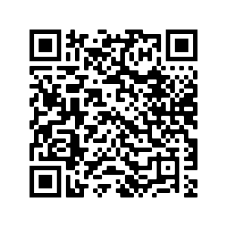http://www.rswebsols.com/tutorials/technology/action-camera-shooting-tips-tricks | 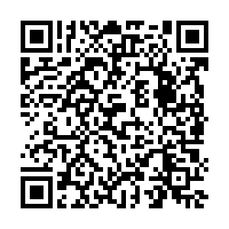https://yellowheadrl.sharepoint.com/:b:/s/Intranet/ESiW7wjdtOtHkq88h7jl1YIBTUFaLygz4oPfkJnWHZPBng?e=E4nA3B

Keyboard
LaunchKey Instructions
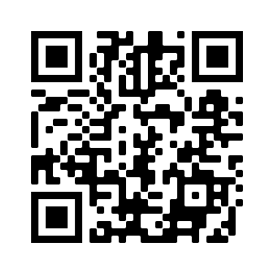https://www.youtube.com/watch?v=oVS3wVA9Yh0 | 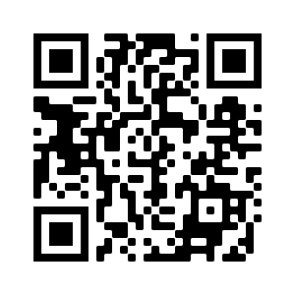https://www.youtube.com/watch?v=yp8_BeVELTg
How-To's
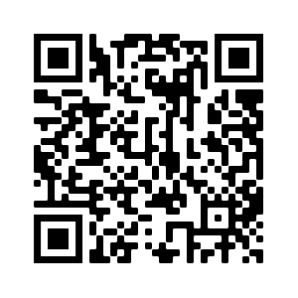  http://takelessons.com/blog/more-easy-pop-songs-piano-z06 | 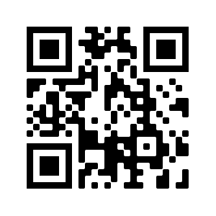  http://www.pianochord.org/

Raspberry Microphone
Instructions and How-To's
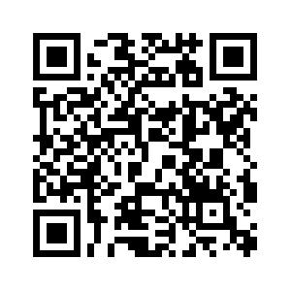https://blog.hubspot.com/marketing/starting-a-podcast-checklist | 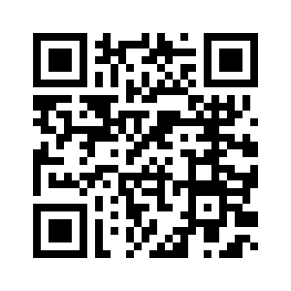https://www.youtube.com/watch?v=zN_dLkilkHA

Ukulele
Instructions and How-To's
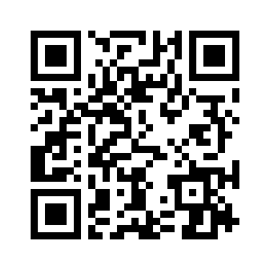 http://www.wikihow.com/Tune-a-Ukulele | 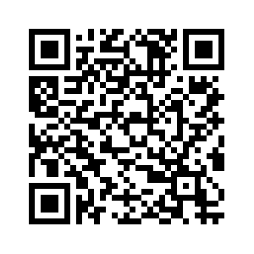 http://www.theukulelereview.com/free-ukulele-lessons/beginner/
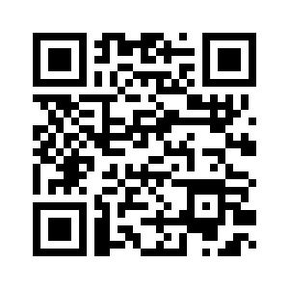 https://liveukulele.com/lessons/fretboard-charts/ | 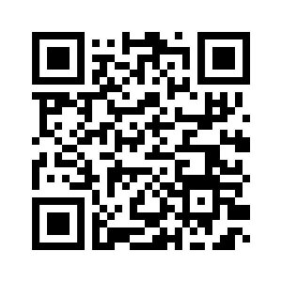 https://www.ukuleleintheclassroom.com/resources_C6.htm

Green Screen & App
The easiest way to use the green screen provided in this kit will be to use it in conjunction with the Green Screen app that is installed on the iPad. Most of the resources provided come from Do Ink, who is the creator and publisher of the Green Screen app on the iPad.
Instructions and How-To's
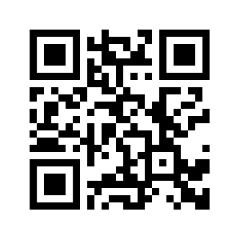  http://www.doink.com/support/ | 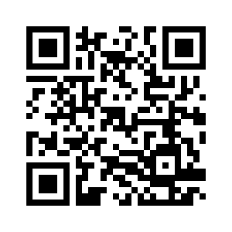http://www.doink.com/tutorials/
Ideas and Projects
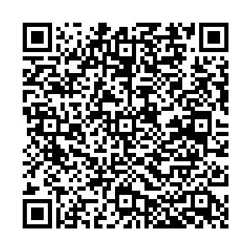 http://drydenart.weebly.com/fugleblog/fuglefun-ways-to-use-green-screen?utm_content=buffer1a802&utm_medium=social&utm_source=twitter.com&utm_campaign=buffer | 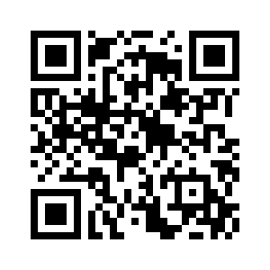https://www.smore.com/e7539-green-screen-activities
Folding Instructions
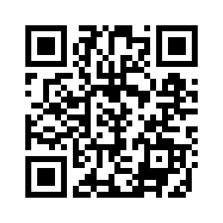
https://www.youtube.com/watch?v=1S9Q6zcfGfo

