Little Makers Kit Resource List

Need to Know:
The following are REQUIRED but not supplied:
- 4 AA batteries for the Code-A-Pillar

Gears! Gears! Gears!
Instructions and How-To's
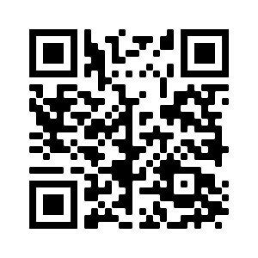
https://www.youtube.com/watch?v=ta9eepPXpAA

Cuby
Instructions and How-To's
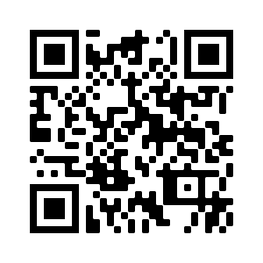http://www.rubiksplace.com/cubes/2x2/ | 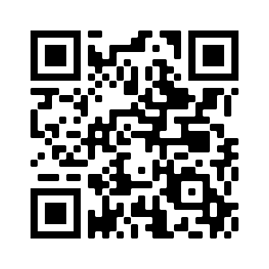  https://rubiks.com/en-US/solve-it

Goldie Blox Craft-Struction
Instructions and How-To's
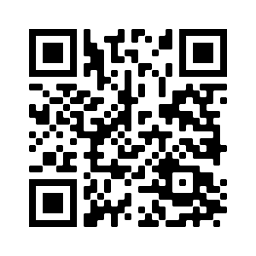  https://www.youtube.com/watch?v=usoErpKaB6w | 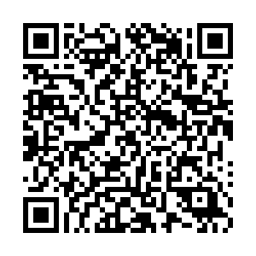 https://yellowheadrl.sharepoint.com/:w:/s/Intranet/ETTT3dLw1i1KjpH8t0ynSWYBAtsLkSkuxkAsE4DXJS-wAw?e=rKbmMe

Game: Littlecodr
Instructions and How-To's
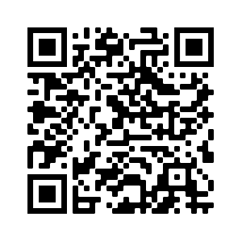  https://www.edsurge.com/research/guides/teaching-kids-to-code | 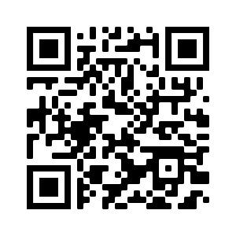https://codebc.ca/resource/littlecodr/

Code-A-Pillar
Instructions and How-To's
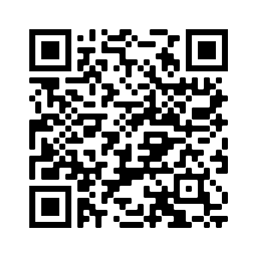
http://service.mattel.com/instruction_sheets/DKT39-Eng.pdf

Brain Flakes
Project Ideas
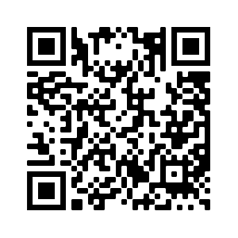 https://www.youtube.com/channel/UCgy5HZETtkVpeAbfdvMR1rw | 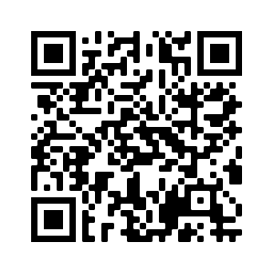  https://www.youtube.com/channel/UCeKDkcQESAObjKTxcDuYrlg/videos

Magnetic Construction set
Project Ideas
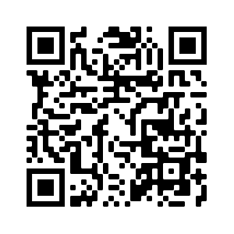
https://www.youtube.com/playlist?list=PLBsEg5oOXnjTWhrpTICK5mjzWEECgQaWr

